DATA HANDLING AND VISUALIZATION(ACTIVITY-1)
NAME:P.NIKITHA
REG NO:192324226 COURSE CODE:DSA0615
1. In an Economic analysis, data is collected on the monthly unemployment rates of a country over many years. Use time-series decomposition to separate the unemployment data into its trend, seasonal, and residual components. Visualize and interpret each component, and discuss how the decomposition helps in understanding the cyclical behavior of unemployment and identifying any long-term changes in the unemployment rate.
- Draw the stacked bar for a given dataset.
- Draw the Pie Plot for a given dataset.
- Draw the Grouped Bar plot for a given dataset.

Month | Economic Condition | Unemployment Rate
Jan | Good | 10.7%
Feb | Good | 9.8%
March | Good | 10.2%
April | Good | 11.2
May | Fair | 15.75%
Jun | Fair | 17.8%
July | Good | 19.4%
August | Bad | 25.6%
Sep | Fair | 18.6%
Oct | Good | !5.6%
Nov | Bad | 26.7%
Dec | Fair | 19.5%

Answer:
Time-Series Decomposi on
Time-series decomposi on splits unemployment data into:
Trend
- Shows the long-term movement in unemployment.
- Helps iden fy whether unemployment is increasing or decreasing over years.
- Useful for policy decisions and economic planning.
Seasonal
- Captures repea ng monthly pa erns.
- For example, unemployment may rise a er certain months due to industry cycles.
- Helps dis nguish regular seasonal effects from real economic problems.
Residual (Irregular)
- Represents random shocks (pandemics, policy changes, crises).
- Helps detect unexpected events affec ng unemployment.
CODE:
rate <- c(10.7,9.8,10.2,11.2,15.75,17.8, 19.4,25.6,18.6,15.6,26.7,19.5,
10.7,9.8,10.2,11.2,15.75,17.8, 19.4,25.6,18.6,15.6,26.7,19.5) ts_data <- ts(rate, frequency = 12) decomp <- decompose(ts_data) plot(decomp)
OUTPUT:

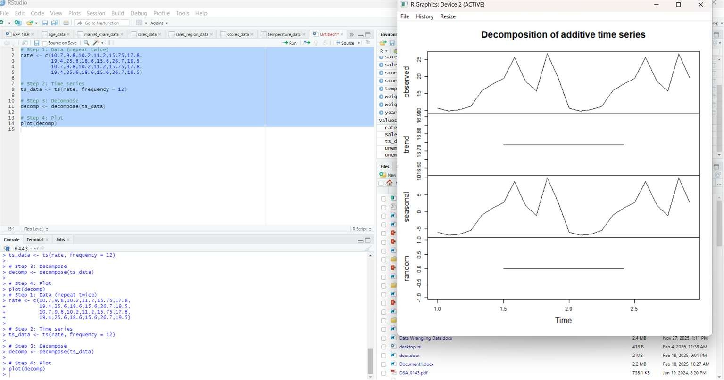
STACKED BAR:
CODE:
rate <- c(10.7,9.8,10.2,11.2,15.75,17.8, 19.4,25.6,18.6,15.6,26.7,19.5) condition <- c("Good","Good","Good","Good",
"Fair","Fair","Good","Bad", "Fair","Good","Bad","Fair") sum_data <- tapply(rate, condition, sum) barplot(sum_data, main="Stacked Bar Plot", xlab="Economic Condition", ylab="Unemployment Rate")
OUTPUT:

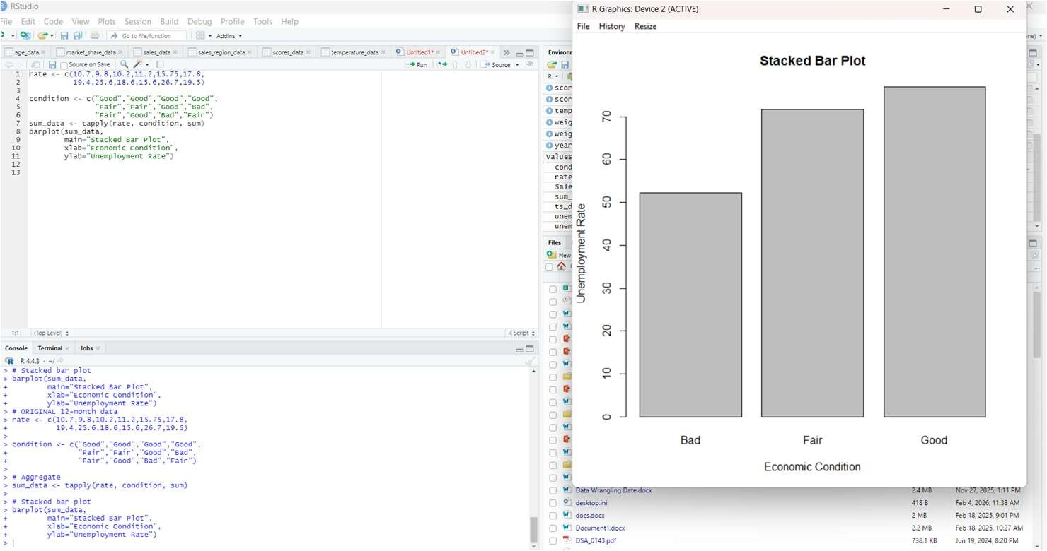

PIE PLOT:
CODE:
pie(sum_data, main="Pie Chart of Unemployment")
OUTPUT:
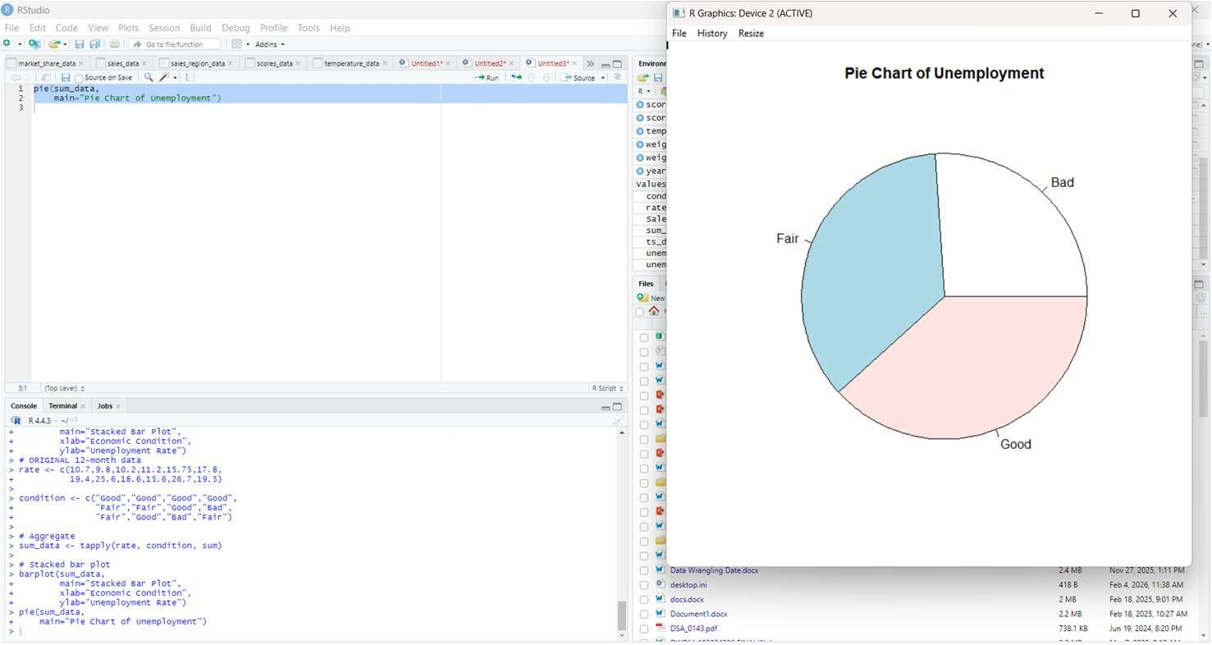

GROUPED BAR PLOT:
CODE:
group_data <- matrix(rate, nrow=3, byrow=TRUE) barplot(group_data, beside=TRUE, main="Grouped Bar Plot", xlab="Month", ylab="Unemployment Rate")
OUTPUT:
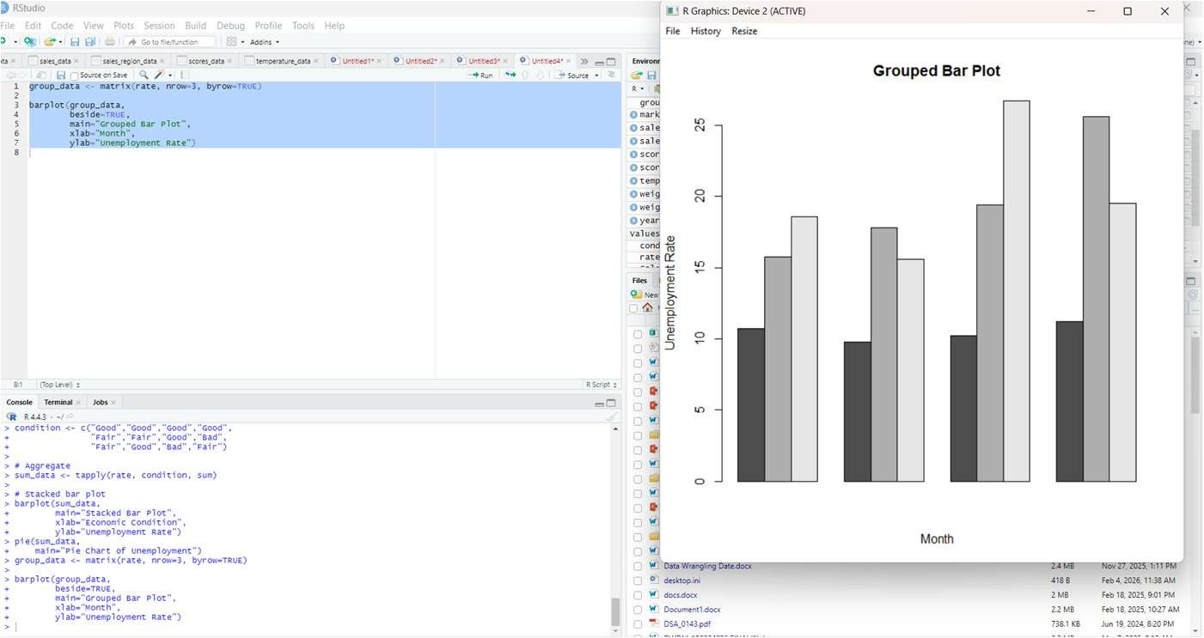

2. Create plots for the below dataset and analyze its efficiency
- Draw the Mosaic Plot for a given dataset.
- Draw the Histogram Plot for a given dataset.
- Draw the Sca er plot for a given dataset.
SCHOOL | GRADE LEVEL | NUMBER OF STUDENTS
A | Grade 1 | 25
A | Grade 2 | 30
A | Grade 3 | 20
B | Grade 1 | 22
B | Grade 2 | 28
B | Grade 3 | 18
C | Grade 1 | 20
C | Grade 2 | 25
C | Grade 3 | 15
D | Grade 1 | 28
D | Grade 2 | 32
D | Grade 3 | 24

ANSWER:
DATASET CODE:
school <- c("A","A","A","B","B","B","C","C","C","D","D","D") grade <- c("Grade1","Grade2","Grade3", "Grade1","Grade2","Grade3",
"Grade1","Grade2","Grade3", "Grade1","Grade2","Grade3") students <- c(25,30,20,22,28,18,20,25,15,28,32,24)

data <- data.frame(school, grade, students)
MOSAIC PLOT CODE:
tab <- table(data$school, data$grade) mosaicplot(tab, main="Mosaic Plot of School vs Grade")
OUTPUT:
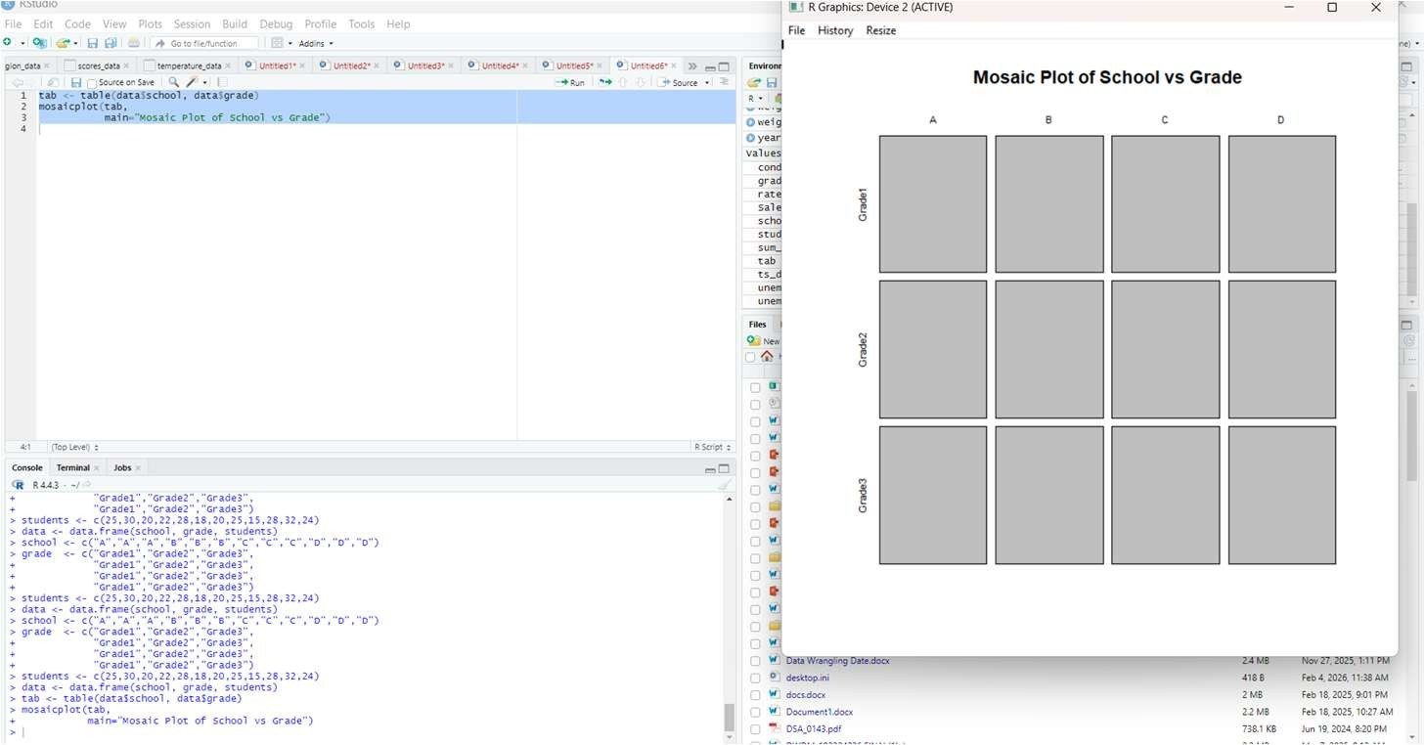

HISTOGRAM PLOT
CODE:
hist(students, main="Histogram of Number of Students", xlab="Number of Students")
OUTPUT:
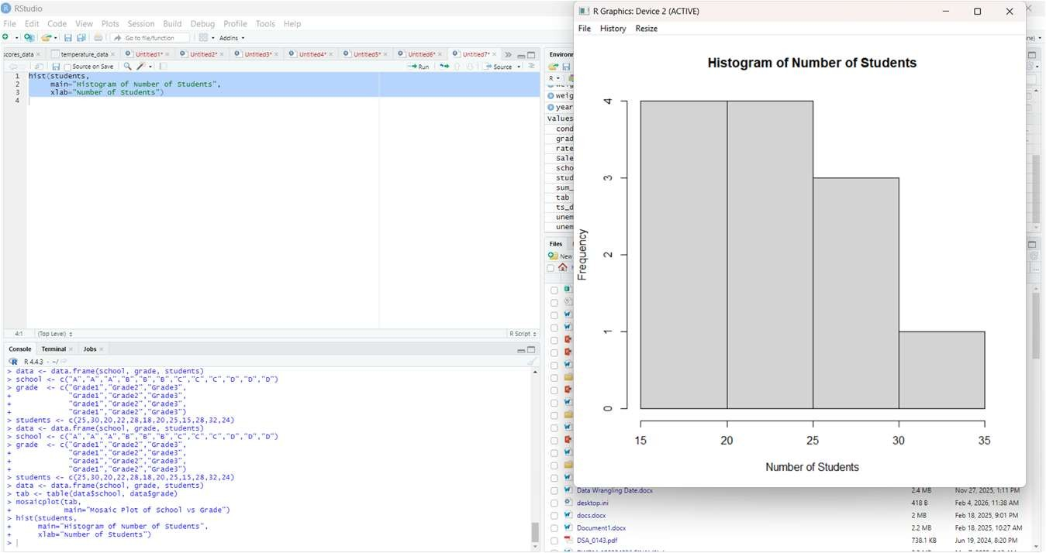
SCATTER PLOT
CODE:
grade_num <- as.numeric(factor(grade))
plot(grade_num, students, main="Scatter Plot", xlab="Grade Level", ylab="Number of Students")
OUTPUT:
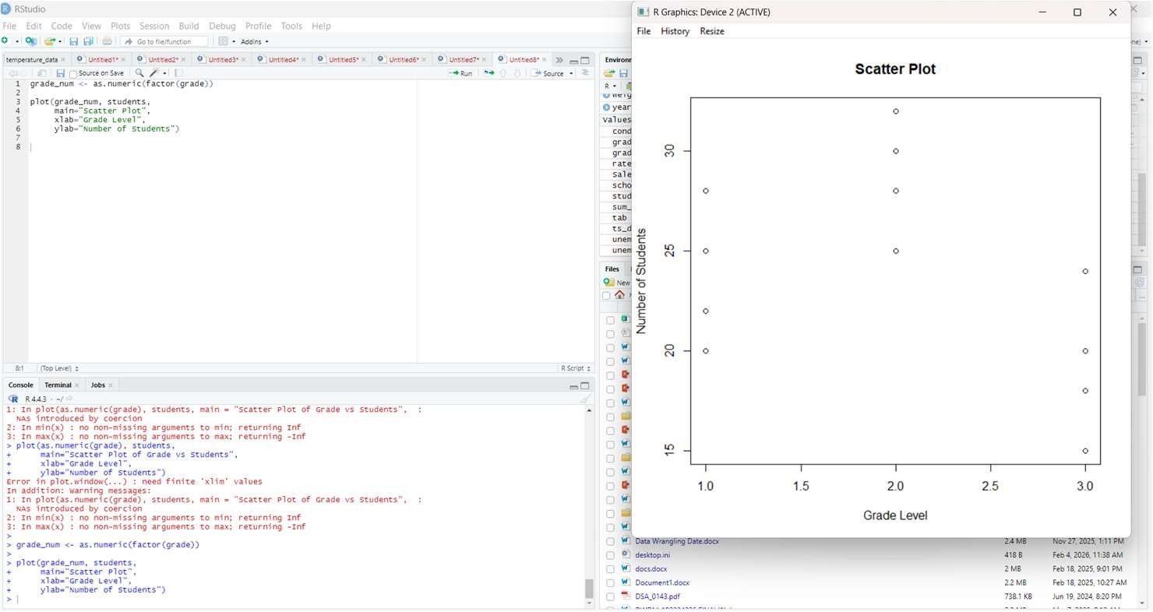
Overall Efficiency Analysis :
Mosaic plots efficiently show categorical relationships, histograms summarize data distribution, and scatter plots reveal patterns between variables. Together, these visualizations provide a clear and efficient understanding of student distribution across schools and grades.

3. Visualize the graphs
- Create a time series plot to visualize the relationship between temperature and precipitation.
- Draw the Line Plot for the given dataset.
- Draw the stacked bar plot for the given dataset.

Date | Station A  Temperature | Station A  Precipitation | Station B  Temperature | Station B  Precipitation
01/01/2024 | 25.0 | 0.1 | 23.5 | 0.2
02/01/2024 | 24.5 | 0.0 | 22.8 | 0.3
03/01/2024 | 26.2 | 0.3 | 25.0 | 0.1
04/01/2024 | 23.8 | 0.2 | 22.5 | 0.0
05/01/2024 | 25.5 | 0.1 | 24.5 | 0.4
06/01/2024 | 23.0 | 0.4 | 21.8 | 0.2

DATA CODE:
date <- as.Date(c("2024-01-01","2024-01-02","2024-01-03", "2024-01-04","2024-01-05","2024-01-06")) tempA <- c(25.0,24.5,26.2,23.8,25.5,23.0) precA <- c(0.1,0.0,0.3,0.2,0.1,0.4) tempB <- c(23.5,22.8,25.0,22.5,24.5,21.8) precB <- c(0.2,0.3,0.1,0.0,0.4,0.2)
TIME SERIES PLOT CODE:
plot(date, tempA, type="l", xlab="Date", ylab="Temperature", main="Time Series Plot") lines(date, tempB)
OUTPUT:
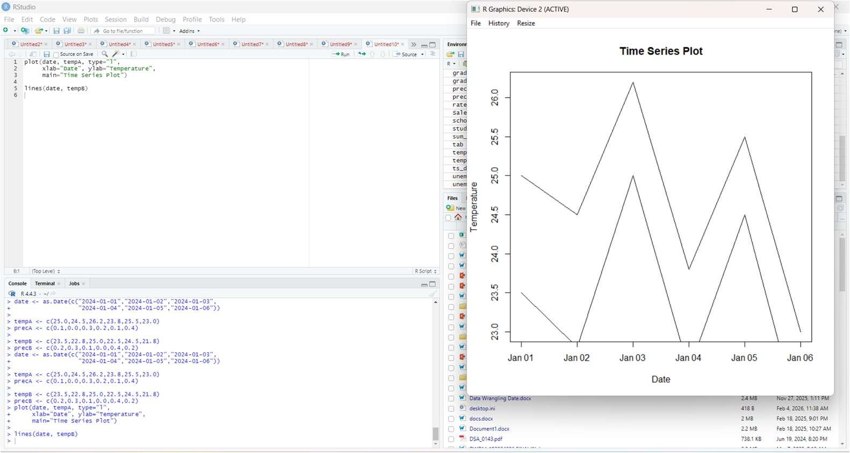
LINE PLOT
CODE:
plot(date, tempA, type="l", xlab="Date", ylab="Temperature", main="Line Plot of Temperature") lines(date, tempB)
OUTPUT:
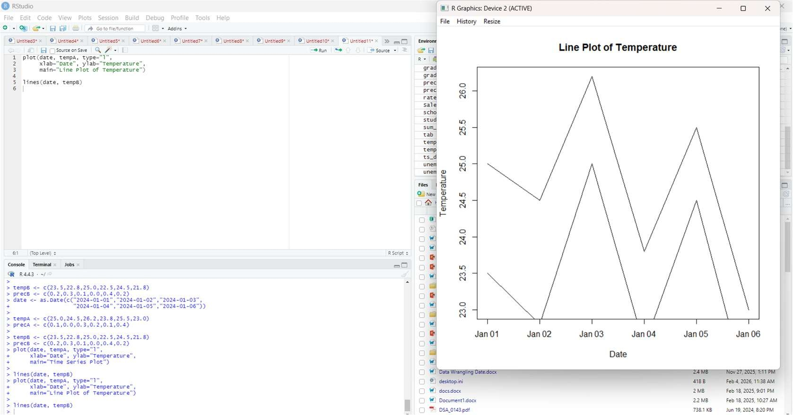
STACKED BAR PLOT CODE:
prec_mat <- rbind(precA, precB) barplot(prec_mat, beside=FALSE, xlab="Date", ylab="Precipitation", main="Stacked Bar Plot of Precipitation")
OUTPUT:
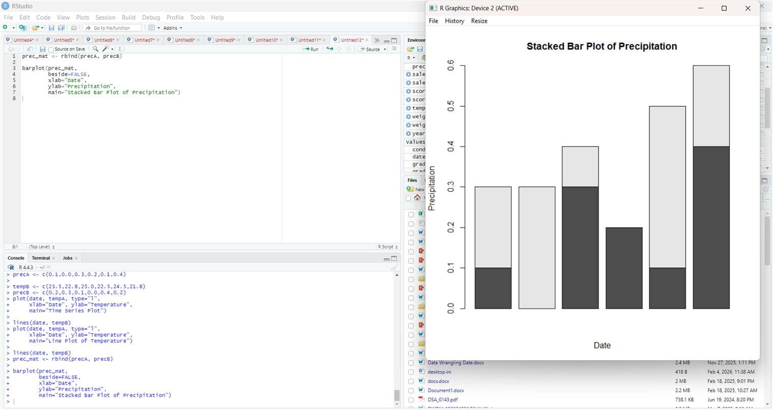

4. The Internet In Real Time – Take 5 years of Internet users with different varie es of browsers to make the data visualized more interac vely.
- Draw the Pie Plot for the given dataset.
- Draw the Mosaic plot for the given dataset.
- Draw the sca er plot for the given dataset.

Year | Browser | Users
2019 | Chrome | 22.7M
2020 | Chrome | 25.8M
2022 | Chrome | 28.7M
2023 | Chrome | 30.5M
2024 | Chrome | 35.2M

DATA:
year <- c(2019, 2020, 2022, 2023, 2024)
browser <- c("Chrome","Chrome","Chrome","Chrome","Chrome")
users <- c(22.7, 25.8, 28.7, 30.5, 35.2)
PIE PLOT CODE:
pie(users, labels = year, main = "Pie Plot of Internet Users (Chrome)")
OUTPUT:
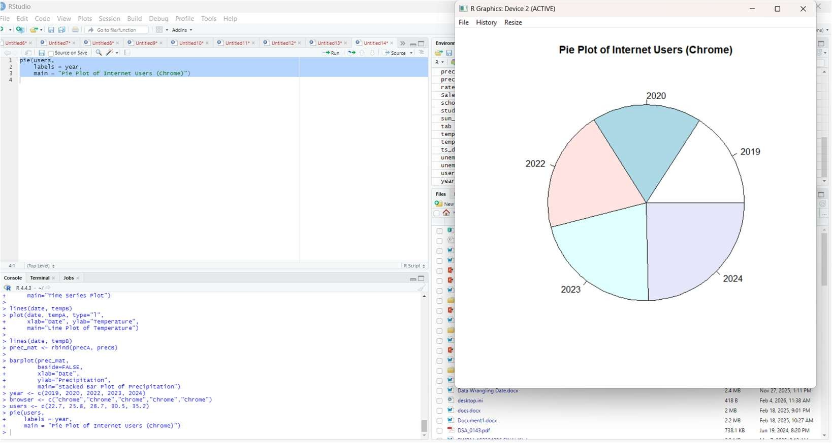
MOSAIC PLOT
CODE:
tab <- table(year, browser) mosaicplot(tab, main = "Mosaic Plot of Year vs Browser")
OUTPUT:
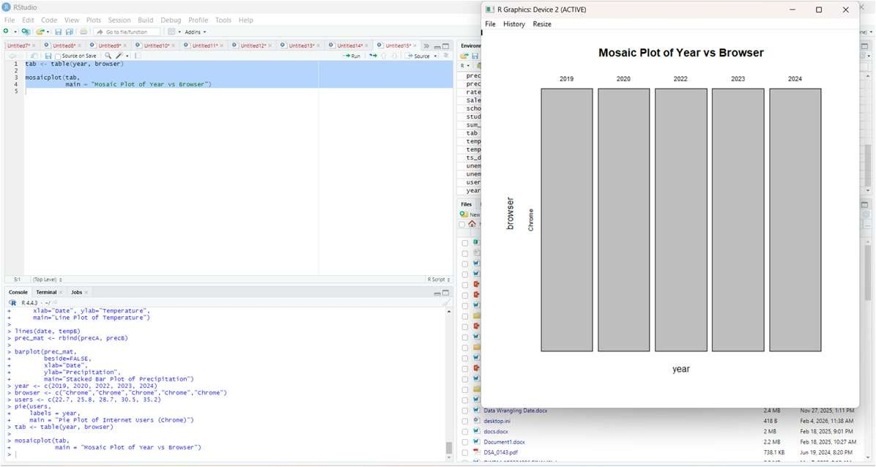
SCATTER PLOT CODE:
plot(year, users, main = "Scatter Plot of Internet Users", xlab = "Year", ylab = "Number of Users (in Millions)")
OUTPUT:
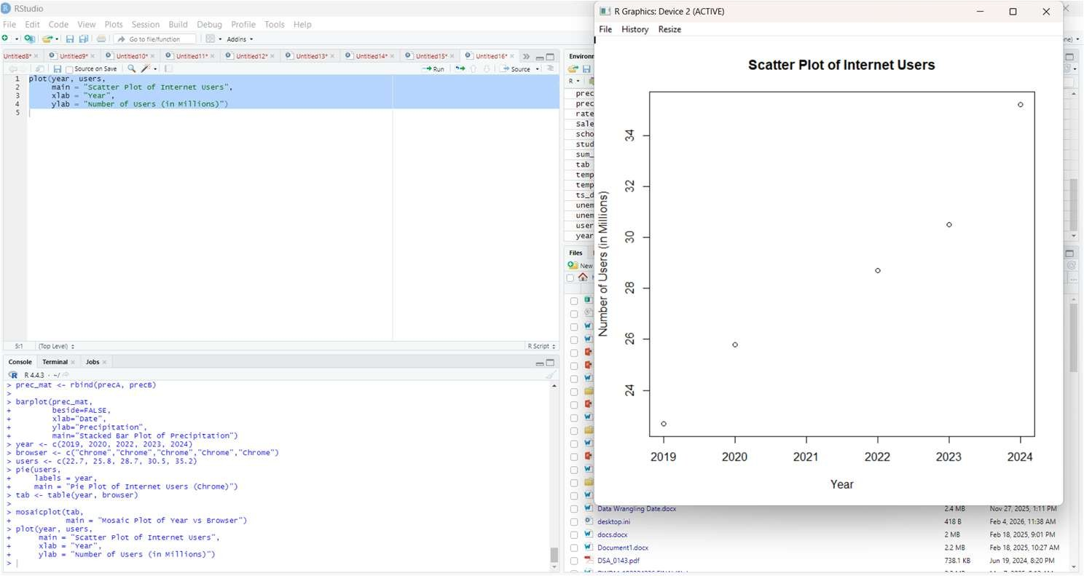

5. The Most Common Jobs by State, 5 years of data about the most common jobs and depict it by year, job wise, and job seekers.
- Draw the Pie Plot for Job seekers' data.
- Draw the Mosaic plot for the given dataset.
- Draw the Funnel plot for the Selec on dataset.

Year | Job Sector | Job Seekers Rate | Selec on Rate
2019 | IT | 95% | 25%
2020 | Government Job | 97% | 12%
2022 | Customer care | 98% | 45%
2023 | Bank | 82% | 20%
2024 | Games | 74% | 35%

DATA:
year <- c(2019, 2020, 2022, 2023, 2024) job <- c("IT", "Government", "CustomerCare", "Bank", "Games") job_seekers <- c(95, 97, 98, 82, 74) selection <- c(25, 12, 45, 20, 35)
PIE PLOT CODE:
pie(job_seekers, labels = job, main = "Pie Plot of Job Seekers Rate")
OUTPUT:
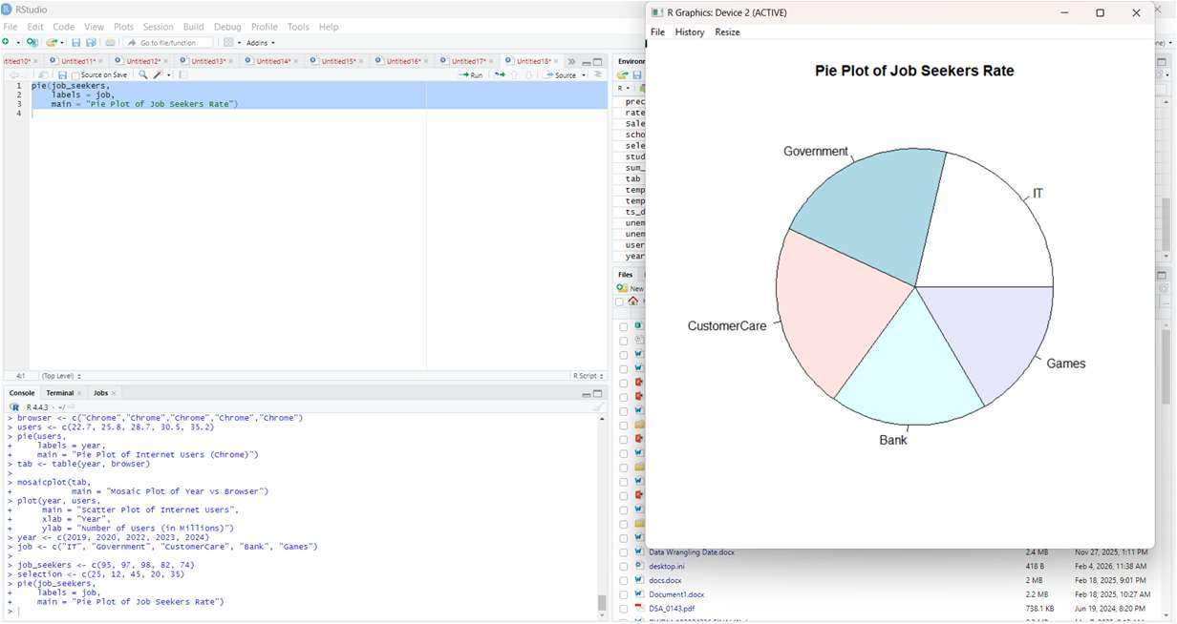
MOSAIC PLOT CODE:
tab <- table(year, job) mosaicplot(tab, main = "Mosaic Plot of Year vs Job Sector")
OUTPUT:
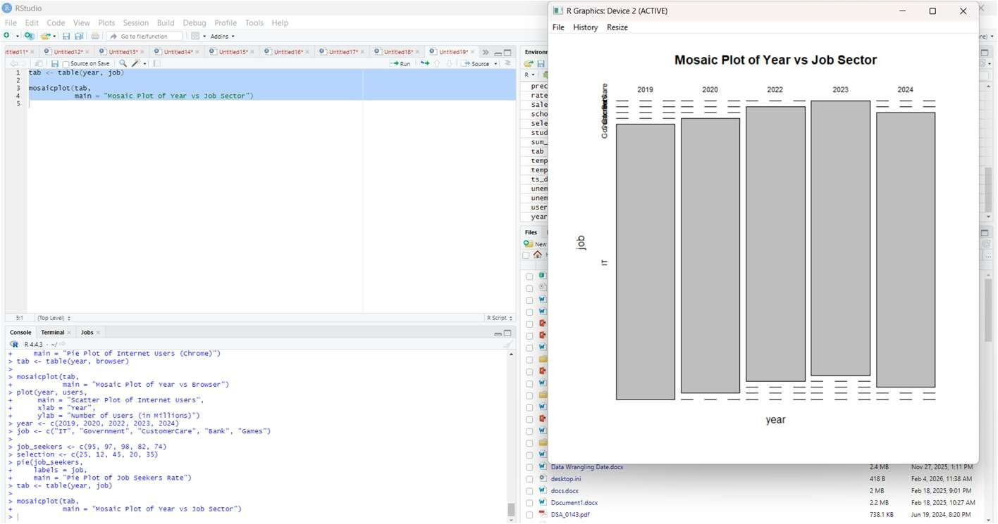
FUNNEL PLOT
CODE:
# Sort data (top to bottom funnel)
selection_sorted <- sort(selection, decreasing = TRUE)
job_sorted <- job[order(selection, decreasing = TRUE)]
barplot(selection_sorted,
names.arg = job_sorted,
horiz = TRUE,
main = "Funnel Plot - Selection Rate",
xlab = "Selection Rate (%)")
OUTPUT:
